XMLCONV Data conversion module
Technical specification
Prepared by
Istvan Alfeldi, European Dynamics
Nedeljko Pavlovic, European Dynamics
July 2007
Version 1.2
Design document
Version management
No | Date | Changes | Author
1.0 | 30/05/05 | Release to EEA | European Dynamics
1.1 | 28/06/05 | Release to EEA | European Dynamics
1.2 | 20/07/2007 | Convert to ODT | Søren Roug

Project manager: Stelios Papastratos
Contents
1. Introduction 5
1.1 Purpose 5
1.2 Scope 5
1.3 Overview 6
2. Decomposition description 6
2.1 Layer decomposition 6
2.2 Module decomposition 8
2.3 Data decomposition 11
3. Dependency description 12
3.1 Intermodule dependencies 12
3.2 GDEM dependencies 13
3.3 DD dependencies 14
3.4 Data dependencies 14
4. Interface description 14
4.1 Module interface 15
5. Detailed design 15
5.1 Module detailed design 15
5.2 Data detailed design 28
5.3 Generated SQL format details 32
6. Deployment view 38
Appendix A - Interactions diagrams 40

References
Title | Author | Version | Date | Location
Call for Tenders No ENV.G.3/SER/2003/0116 "Technical specifications for the provision of information technology services to support the development of a wider REPORTNET"
Kick-off Meeting Minutes (24/01/2005) | Stelios Papastratos | 1.1 | 08/02/2005 | http://eea.eionet.eu.int/Members/irc/eionet-circle/eionet-telematics/library?l=/reportnet_project/specialist_files/wp01/reportnet-mom-050124-kom/_EN_1.1_&a=d
Development Procedures | Soren Roug | 1.0 | 25/01/2005 | http://eea.eionet.eu.int/Members/irc/eionet-circle/eionet-telematics/library?l=/reportnet_project/specialist_files/wp01/kickoff-rougppt/_EN_1.0_&a=d
List of Questions/Answers - Zope/Python-J2EE Comparison | Nedeljko Pavlovic  Stelios Papastratos | 1.0 | 31/01/2005 | http://eea.eionet.eu.int/Members/irc/eionet-circle/eionet-telematics/library?l=/reportnet_project/specialist_files/wp01/reportnet-wd-kom-v002doc/_EN_1.0_&a=d
Web site design guidelines | EEA |  | 2004 | http://www.eionet.eu.int/software/design
Functional Specifications document | Nedeljko Pavlovic  Istvan Alfeldi | 1.1 | 25/03/2005 | http://eea.eionet.eu.int/Members/irc/eionet-circle/eionet-telematics/library?l=/reportnet_project/specialist_files/wp04_conversion/conversion_v10doc/_EN_1.1_&a=d
Document conventions
Acronyms/Abbreviations:
CDR Central Data Repository
DCM Data Conversion Module a.k.a XMLCONV
DD Data Dictionary
DMM Data Merging Module
DTML Document Template Mark-up Language
EEA European Environment Agency
TSD Technical Specifications Document
EIONET The European Environmental Information and Observation Network
HTTP Hypertext Transfer Protocol
REQ Each requirement is uniquely identified by a REQ and an appropriate sequence number
RDF Resource Description Framework
RSS Really Simple Syndication
SMTP Simple Mail Transfer Protocol
TCP/IP Transmission Control Protocol / Internet Protocol
XML Extensible Mark-up Language
XML-RPC Remote procedure calling using HTTP as the transport protocol and XML as the encoding protocol.
XMPP Extensible Messaging and Presence Protocol
UI User Interface

Introduction

Purpose
A Technical specifications document (TSD) is a representation of the software system that is used to facilitate analysis, planning, implementation, and decision making. The present TSD refers to the REPORTNET Data Conversion Module.

Scope
The purpose of the data conversion module is to convert delivered XML files to SQL scripts and to simple HTML tables. The DCM will improve automation of reporting and contribute to the development of a European level data exchange format in order to ease exchange, transparency and access to environmental information.

Overview
The structure of the document is as follows:
Section 2 (Decomposition Description) offers several views on how to decompose the total structure of the REPORTNET Data Conversion Module system. The system can be decomposed in four different views:
- Layer decomposition;
- Module decomposition;
- Data decomposition
In terms of layer decomposition the system is decomposed in the following layers:
- Presentation layer;
- Business logic layer;
- Enterprise resources abstraction layer;
- Enterprise resources layer.
In terms of module decomposition the system is decomposed in the following modules:
- GUI Module (belongs to presentation layer)
- Admin Module (belongs to business logic layer)
- Conversion Module (belongs to business logic layer)
- Table Definition module (belongs to business logic layer)
- Data access module (belongs to business logic layer)
Section 3 provides information about inter-module and data dependencies. Section 4 provides a description of the interfaces for the various modules. Section 5 presents the detailed design of each module.

Decomposition description
This section offers several views on how to decompose the total structure of the REPORTNET Data Conversion Module. Emphasis will be placed on general layering, modularity, processes, and the general structure of data.

Layer decomposition
The REPORTNET Data Conversion Module logical partitioning consists of application layers that collaborate together through well-defined interfaces, but do not share internal knowledge about each other. This not only makes the structure and design of the DCM easier to understand, but it also has scaling implications. Since each layer communicates with the one below it using well-known interfaces, it is a simple matter to replace any one of the layers as long as the new layer presents an identical interface.
The DCM consists of the layers described below:

Presentation layer
The presentation layer handles the layout, formatting, and display of query results to users. This layer provides views of data to users of the DCM. The DCM presentation layer is concerned only with providing a user interface that enables the DCM users to interact with the system.

Business logic layer
This layer implements most of the REPORTNET Data Conversion Module functions, which has the overall control of events and notifications processing and it provides a software representation of objects that users deal with when interacting with the DCM.

Enterprise resources abstraction layer
This is an object abstraction layer wrapping the enterprise resources. In the DCM design model, Java classes are normally used.

Enterprise resources layer
This layer comprises non-Java resources storing raw data. It consists of MySQL Database, OpenLDAP and File system.
For each module described in section 2.2.1 the layer in which the module is placed will be pointed out.

Module decomposition
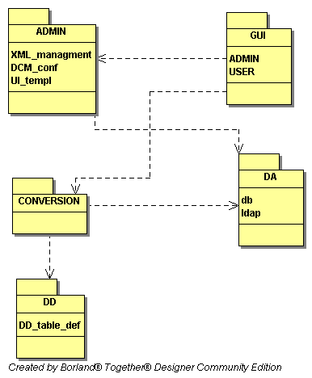
Figure 1 - Data Conversion Module and dependencies

GUI module
The GUI module represents the conceptual module that contains all objects related to the DCM user interface. This module, as well as its leaf modules, belongs to the REPORTNET Data Conversion Module presentation layer. Section 5.1.1 presents the detailed design of the DCM GUI module.

Administration GUI
The administration user interface will allow EIONET Administrators access to administrative functions of the DCM. The following list represents the functions that will be accessible through the administrative user interface:
- XML schema and stylesheet management
- DCM configuration
- UI templates management

User’s GUI
User’s graphical user interface will allow EIONET Users to access the DCM functionalities responsible for conversion and validation functionalities. The following list represents these functions:
- Validate XML file
- Convert XML file
- Login. Login will be needed in order to access to the administrative features of the DCM.

Admin module
The admin module is a conceptual module that contains core functionalities related to the EIONET Administrator. Physically it represents a Java package. This module and its leaf modules belong to the REPORTNET GDEM and DCM business logic layer.

Manage XML schema and stylesheet
This module provides functionalities related to hand coded XML schema and stylesheet management. It will provide the following functions:
- Add XML schema
- Remove XML schema
- Add stylesheet
- Remove stylesheet
This module belongs to the REPORTNET DCM business logic layer. Section 5.1.2 presents the detailed design of the XML schema and stylesheet management module.

DCM configuration management module
The DCM configuration module will consist of the functions related to setting up the REPORTNET Data Conversion Module. In what follows we present the list of functions for this module:
- Set up MySQL Database configuration parameters
- Set up LDAP Server configuration parameters
- Set up DD parameters
This module belongs to the REPORTNET DCM business logic layer.

UI templates management module
This module will provide core functionalities related to the management of basic design elements of the DCM User interface. The functions provided by this module are the following:
- Modify header
- Modify footer
This module belongs to the REPORTNET DCM business logic layer.

Conversion module
The conversion module is a conceptual module that contains core functionalities related to the XML conversion and validation functions. This module and its leaf modules belong to the REPORTNET Data Conversion Module logic layer. Section 5.1.3 presents the detailed design of the Conversion module.

XML validation module
The XML validation module will provide functions which will validate XML files against the XML schemas.

XML Conversion module
The XML conversion module will provide functions which will convert XML files using a predefined stylesheet.

Get list of conversions
The Get list of conversions module will provide functions which will retrieve conversions from the DCM.

Stylesheet Generation module
The Stylesheet Generation module will provide functions which will generate stylesheet for tables which are defined in DD.

Table Definition module
The Table Definition module is a conceptual module that contains core functionalities related to the Table Definition. This module is part of the DataDictionary system. Section 5.1.4 presents the detailed design of the Conversion module.

Data access module
The Data access module provides functions that are responsible for accessing the raw data and assembling this raw data to the software objects. This module belongs to the REPORTNET DCM business logic layer. Section 5.1.5 presents the detailed design of the Data access module.

Data decomposition
The data handled in the DCM consist of a few real world entities. These entities are described here conceptually. Therefore, this section contains a conceptual model of all data entities, which can then be readily translated into a database schema. The Database Schema will be presented in section 5.2.1. The following figure represents the DCM logical data model.
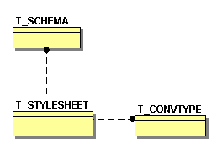
Figure 2 - The DCM ER diagram

T_CONVTYPE
T_CONVTYPE represents conversion types.
- CONV_TYPE: Name of the conversion type.
- CONTENT_TYPE: Content type of the conversion.
- FILE_EXT: File extension of the conversion.
- DESCRIPTION: Description of the conversion.

T_SCHEMA
T_SCHEMA represents hand coded schema.
- XML_SCHEMA: The URL of the xml schema.
- DESCRIPTION: The Description of the xml schema.
- DTD_PUBLIC_ID: DTD_PUBLIC_ID of the XML Schema
- VALIDATE: Validation flag. Value 1 or 0, default value is 0.

T_STYLESHEET
T_STYLESHEET represents hand coded stylesheet.
- DESCRIPTION: The Description of the Stylesheet.
- RESULT_TYPE: The Result type of the Conversion.
- XSL_FILENAME: The XSL file name.

Dependency description

Intermodule dependencies
The REPORTNET DCM depends on the following list of the external java libraries:
- Apache Struts framework version 1.2.4
- File upload component for Java servlets version 1.0
- eionet-dir current version
- log4j version 1.1.3
- Sun Microsystems Inc. saxon version 1.4.1_02
- uit-client current version
- uit-security current version
- Sun Microsystems Inc. xalan version 1.2.2
- xercesImpl version 2.6.2
- xmlrpc current version
- xmlserver current version
- EEA ACL API current version
- MySQL-connector version 3.1
The following modules rely on other modules that are part of the REPORTNET Data Conversion Module:
- GUI Module. This module depends on the Admin, Conversion and Data access modules. Moreover, this module depends on Apache Struts framework libraries. Conceptually this dependence represents the connection between the DCM presentation layer and the business logic layer.
- Admin GUI module. This module uses the Admin module in order to accomplish tasks requested by the EIONET Administrators. It also depends on the Data access module in order to provide data to the underlying business logic.
- Users GUI module. This module uses the Conversion modules in order to accomplish tasks requested by the EIONET Users. It also depends on the Data access module in order to provide data to the underlying business logic.
- Admin module. This module uses the Data access module in order to provide data and store data.
- Conversion module. This module uses the Table definition module in order to retrieve data table definition from DD and also uses the saxon, uit-client, xalan, xercesImpl, xmlrpc, xmlserver external libraries. It also depends on the Data access module in order to obtain the results provided by the underlying business logic.
- Table Definition module. This module is part of the DD system and it depends on the DD Data access module.
- Data access module. This module depends on the MySQL-connector external library.

GDEM dependencies
The Data Conversion Module will be developed inside the GDEM system. DCM uses most of the GDEM modules with some modifications so there will be many dependencies. This section describes the dependencies between DCM and GDEM.

GUI dependences
Part of the GDEM GUI which is responsible for the conversions will be re-factored. The GUI module will be developed in the struts framework and GUI module will support UI template management.

Conversion module dependences
The DCM conversion module will use the GDEM conversion module with some modifications. Modifications include adaptations for DD tables conversion.

Data access module dependences
The DCM will use the existing GDEM data access module and all data access functions will be added in GDEM access module in the DbModule class. The DCM will use the existing GDEM’s database.

Validation module dependences
The DCM will use the existing GDEM validation module. The GDEM validation module uses XML schemas generated in DD in order to validate the delivered XML file. This module depends on the GDEM validation module and on the DD module responsible for the XML schema generation.

XmlRpcRouter module dependences
The DCM will use the existing GDEM XmlRpcRouter module as a XMLRPC server so all XmlRpc communications use this module.

DD dependencies
The module in DD responsible for the XML schema generation will be recoded in order to support validation in the DCM conversion module. This module depends on the DD system.

Data dependencies

Mapping Procedure
The mapping of the conceptual domain model to the database schema will be constructed using the following rules:
- Every concept should correspond to at least one entity.
- Attributes are mapped directly if they represent a type of attributes native to the MySQL 4.1 Database System.
- Attributes that refer to concepts in the domain model are mapped to a foreign key attribute that uniquely identifies the entity in the schema.
- If the relationship between entities has a many-to-many role this relationship is expanded into a separate table, where both foreign keys are united as the primary key of the relation.

Interface description
This subsection describes the type of information that designers, programmers and testers need to know in order to use correctly the functions provided by the DCM modules. It includes the details of internal interfaces not provided in the REPORTNET DCM Specifications Document.

Module interface

GUI module
The interface to the REPORTNET Data Conversion GUI module and all its leaf modules is provided by the Tomcat application server. The GUI module will be accessed by the EEA users.

Admin Module

XML schema and stylesheet management
The interface to XML schema and stylesheet management module is provided by the public methods of the AdminService class. The Administration GUI module uses this interface.

Conversion module
The interface to the Conversion module is provided by the public methods of the ConversionService class and by the public method of ValidationService class. These methods will be called by the XML-RPC protocol and by the GUI Module.

Table Definition module
The interface to the Table Definition module is provided by the servlet. These methods will be called by the HTTP protocol from the Conversion Module. This servlet is part of DD. The servlet class is the TblXmlMetaServlet class.

Data access module
The interface for this module is determined by the IDbModule java interface. The Admin and Conversion module use this interface.

Detailed design

Module detailed design
The section presents the internal details of each DCM module. These details include attribute descriptions for identification, processing and data. It also contains the details that will be needed by the programmers for the relevant implementations.

GUI module
The REPORTNET GUI module is implemented with strict adherence to the MVC design pattern by using the Apache Struts framework. The Apache Struts framework is a set of cooperating classes, java servlets, and JSP tags that make up a reusable MVC design.
The individual components are as follows:
- Model. Model is responsible for providing the data from the enterprise resources, for saving the data into the data stores and for wrapping the business logic objects. Data entered by the user through View are checked in the model before submitted to the underlying business logic.
- Controller. The Controller receives the request from the browser and decides where to send the request. With Apache Struts framework, the Controller is a command design pattern implemented as a servlet.
- View. The DCM view represents the user view of the application and is responsible for taking the input from the user, dispatching the request to the controller and then receiving response from the controller and displaying the result to the user. HTML, JSPs, Custom Tag Libraries and Resources files are the parts of the view component. There is no flow logic, no business logic, and no model information.
GUI module contains two sub modules namely, the Administration GUI module and the User’s GUI module. The Administration GUI and User’s GUI modules will be implemented following the usual Struts implementation.

XML schema and stylesheet management module
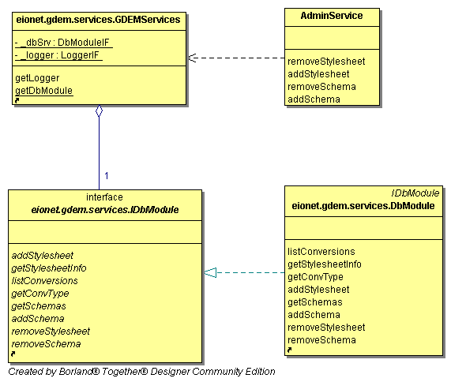
Figure 3 - The XML schema and stylesheet management module class diagram

AdminService class
This class contains all schema and stylesheet management functions. These functions are called by the GUI module.
Attributes:
Methods:
- addSchema(String xmlSchema, String description, String public_id)
This method inserts a new hand-coded XML schema. This method is called by the GUI module and calls the addSchema method from DbModule.
- removeSchema(String schemaId)
This method removes a hand-coded schema. This method is called by the GUI module and calls the removeStylesheet method from DbModule.
- addStylesheet(String xmlSchemaID, String resultType, String xslFileName, String description)
This method inserts a new hand-coded stylesheet. This method is called by the GUI module and calls the addStyleshhet method from DbModule
- removeStylesheet(String convertId)
This method removes a hand-coded stylesheet. This method is called by the GUI module and calls the removeStyleshhet method from DbModule

Conversion module
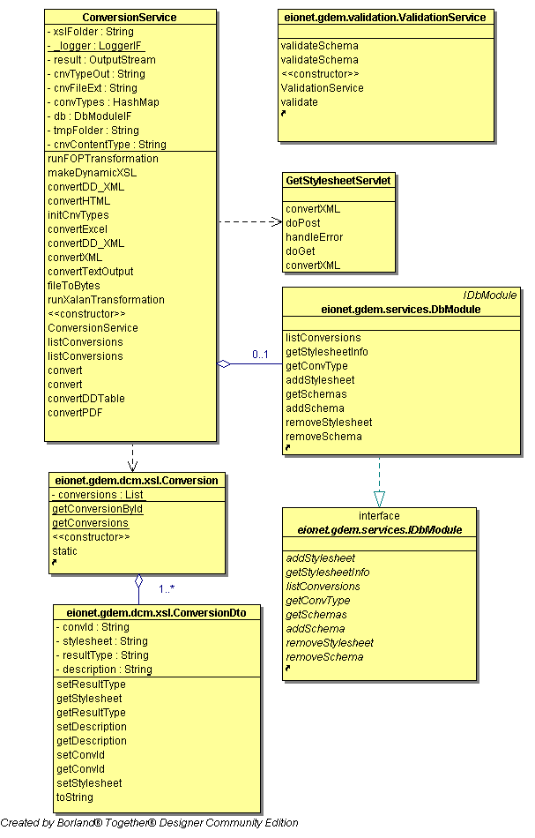
Figure 4 - The Conversion module class diagram

ConversionService class
This class contains all conversion business functions called from the GUI module, as well as through XML-RPC.

Attributes:
Methods:
- ConversionService ()
Constructor of the ConversionService class.
- listConversions()
Returns a List of all conversions defined in DCM. That includes all hand-coded conversions and all conversions for tables defined in DD. This method calls the listConversions method from DbModule class. This method is called from the GUI module and from the XmlRpcRouter module.
- listConversions(schema)
Returns a List of all conversions defined in DCM for a requested schema. The schema parameter represents the XML schema URL. This method is called from the GUI module and from the XmlRpcRouter module. This method calls the listConversions method from DbModule class. This method is implementation of the Get list of conversion module 2.2.3.3. This method returns the list of the conversions available for the requested XML schema. If XML schema is generated in DD then the result is a list with all handcoded conversions for the requested schema and all the generated conversions defined in Conversion XML file.
- convert(sourceURL,convertId)
Returns a Hashtable with the results of the Conversion for a requested XML file using the identifier of the conversion. The sourceURL parameter represents the XML file URL. The convertId represents the identifier of the conversion. This method is called from the XmlRpcRouter module and calls the convert (sourceURL, converted, res) method from the same class.
- convert(sourceURL, convertId, res)
Returns a Hashtable with the results of the Conversion for a requested XML file using the identifier of the conversion. The sourceURL parameter represents the XML file URL. The convertId represents the identifier of the conversion. res is an HttpServletResponse object. The res object is used when the ConversionService method is called by the GUI module. This function is implementation of the XML conversion module 2.2.3.2.
If convertId starts with DD then this method calls the convertDDTable method from the same class in order to perform conversion of the delivered file which is defined in DD. If convertId doesn’t start with DD then the conversion is carried out using a hand-coded stylesheet. This method calls the getStylesheetInfo and getConvType from class DbModule in order to retrieve the conversion data. This method also calls methods from the xalan external library for conversions.
- convertDDTable(sourceURL, convertId, res)
Returns a Hashtable with the results of the Conversion for a requested XML file using the identifier of the conversion. This function converts XML files which are defined in DD. The sourceURL parameter represents the XML file URL. The convertId represents the identifier of the conversion. res is an HttpServletResponse object. The res object is used when the ConversionService method is called by the GUI module. This method calls the GetStylesheetServlet class in order to retrieve the stylesheet for the conversion.
- makeDynamicXSL(String sourceURL, String convertId,HttpServletResponse res) Generates the Stylesheet for the Conversion. This method is called by the GetStylesheetServlet servlet. This method calls TblXmlMetaServlet in order to retrieve the definition of table as defined in DD. This method uses the table definition XML and the Meta Stylesheet file in order to generate the stylesheet for the conversion of the delivery XML. For the conversion this method calls methods from the xalan external library.

ConversionDto class
This class represents the Data Transfer Object for table conversions as defined in DD. This class holds one conversion defined in Conversion XML file.

Attributes:
  - convId
represents the identifier of the Conversion
  - stylesheet
represents the Name of the meta XSL file
  - resultType
represents the result type of the Conversion
  - description
represents the Description of the Conversion
Methods:
The ConversionDto class has getters and setters methods for all attributes.

Conversion class
This class holds all defined Conversions from the Conversion XML file and all business operations related with Conversions.
Attributes:
  - conversions
is List of ConversionDto Objects

Methods:
- Static constructor
Static constructor which populates the conversions attributes from the Conversion XML file.
- getConversions ()
Returns a list of conversions.
- getConversionById (convId)
Returns ConversionDto with the convId attribute.

GetStylesheetServlet class
This class extends the HttpServlet class and it is used for generating the Stylesheet for the requested DD table Conversion. This Class is implementation of the Stylesheet Generation module 2.2.3.4.
Attributes:

Methods:
- doPost( HttpServletRequest req, HttpServletResponse res )
This method calls the doGet method.
- doGet(HttpServletRequest req, HttpServletResponse res)
This method requests the id and conv parameters. The Id parameter represents the table identifier in the DD. The Conv parameter represents the identifier of the conversion defined in the Conversion XML file. This method calls the makeDynamicXSL method from ConversionService class.

ValidationService class
This class is used for validating delivered XML files. This Class is implementation of XML Validation module 2.2.3.1.
Attributes:

Methods:
- ValidationService()
Constructor of the class.
- validateSchema (String srcUrl, String schema)
This method is called from the GUI module and from the XmlRpcRouter module. This method calls the validateSchema (InputStream src_stream, String schema) method from the same class.
- validateSchema (InputStream src_stream, String schema)
This method validates the XML file from src_stream against the XML schema. This method uses Java API for XML Processing as an external library. This method uses the generated XML Schema from DD from tables which are defined in DD.
- validate (String srcUrl)
This method is called from the GUI module and from the XmlRpcRouter module. This method calls the validateSchema (InputStream src_stream, String schema) method from the same class.

Table Definition module
The Table Definition module is part of the Data Dictionary system. This module generates XML with table definitions used in Stylesheet generation module. Section 5.2.4 presents the detailed format of the DD Table Definition XML.
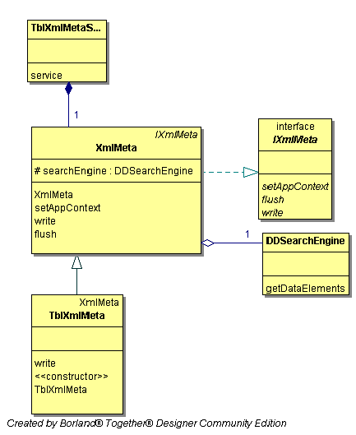
Figure 5 - The Table Definition module class diagram

DDSearchEngine class
This Class provides functions that are responsible for accessing and assembling data from the DD database.
Attributes:
Methods:
- getDataElements(Vector params,String type,String namespace,String short_name)
Retrieves data elements definition from the DD database. This method is called from the XmlMeta class.

IXmlMeta interface

Attributes:
No attributes

Methods:
- setAppContext (appContext)
Sets the request URI up to the servlet name.
- flush ()
Flushes the written content into the writer.
- write (objID)
Writes an XML instance for the given object.

XmlMeta class
This class implements the IXmlMeta interface and prepares the XML document.

Attributes:
Methods:
- XmlMeta (searchEngine, writer)
Constructor of the Class

TblXmlMeta class
This class extends the XmlMeta class and prepares the XML document using the table definition. TblXmlMetaServlet class calls methods of this class.

Attributes:
Methods:
- TblXmlMeta (searchEngine, writer)
Constructor of the Class. The searchEngine parameter is a DDSearchEngine object. The writer parameter is a java.io.PrintWriter object.
- write(String tblID)
Retrieves the table definition and writes it to the writer object.

TblXmlMetaServlet class
This class extends the HttpServlet class and is responsible for the DD Table Definition XML generation.

Attributes:

Methods:
- service(HttpServletRequest req, HttpServletResponse res)
This method calls methods from the TblXmlMeta class in order to prepare the table definition XML. This method is called from the ConversionService class.

Data access module
The data access module is responsible for accessing data and other database manipulation business logic functions.
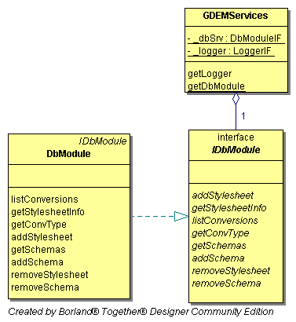
Figure 6 - The Data access module class diagram

GDEMServices class
This Class is a container for the DbModule objects.

Attributes:
  - _dbSrv
holds DbModule objects
Methods:
- getDbModule()
Returns IDbModule Retrieves data elements definition from the DD database.

IDbModule interface

Attributes:
No attributes
Methods:
- listConversions(String xmlSchema)
Returns a vector of hand-coded conversions for the requested XML Schema.
- getStylesheetInfo(String convertId)
Returns a Hashtable with conversion data for the requested conversion identifier.
- getConvType(String conv_type)
Returns a Hashtable with conversion data types for the requested conversion type.
- getSchema(String schema_id)
Returns a HashMap with schemas data for the requested schema identifier.
- addStylesheet(String xmlSchemaID, String resultType, String xslFileName, String description)
Creates a new hand-coded stylesheet.
- addSchema(String xmlSchema, String description, String public_id)
Creates a new hand-coded XML schema.
- removeStylesheet(String convertId)
Removes a hand-coded stylesheet.
- removeSchema(String schemaId)
Removes a hand-coded XML schema.

DbModule class
This class implements the IDbModule interface.

Data detailed design

Database schema
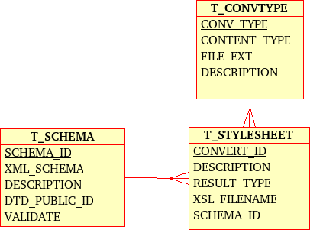Figure 7: The DCM Database physical data model diagram
This section aims at providing a detailed description of the physical data model of the REPORTNET DCM. All the DCM Database tables are described in detail in the tables below.
T_CONVTYPE
ColumnName | DataType | PrimaryKey | NotNull | Flags | Default Value | Comment | AutoInc
CONV_TYPE | VARCHAR(50) | PK | NN |  |  | Unique identifier of the conversion type
CONTENT_TYPE | VARCHAR(100) |  | NN |  | text/plain | Conversion type
FILE_EXT | VARCHAR(20) |  | NN |  | txt | Conversion File result extension
DESCRIPTION | VARCHAR(255) |  |  |  |  | Conversion description
T_SCHEMA
ColumnName | DataType | PrimaryKey | NotNull | Flags | Default Value | Comment | AutoInc
SCHEMA_ID | INTEGER(11) | PK | NN |  |  | Unique identifier of the schema type
XML_SCHEMA | VARCHAR(255) |  | NN |  |  | Schema URL
DESCRIPTION | VARCHAR(255) |  |  |  |  | Description
DTD_PUBLIC_ID | VARCHAR(255)
VALIDATE | ENUM('0','1')
T_STYLESHEET
ColumnName | DataType | PrimaryKey | NotNull | Flags | Default Value | Comment | AutoInc
CONVERT_ID | INTEGER(11) | PK | NN |  |  | Unique identifier of the stylesheet
DESCRIPTION | VARCHAR(255) |  |  |  |  | Description
RESULT_TYPE | VARCHAR(50) |  | NN |  | HTML | Result type
XSL_FILENAME | VARCHAR(255) |  | NN |  |  | Hand-coded stylesheet file name
SCHEMA_ID | INTEGER(11) |  | NN |  |  | The unique identifier of the referenced schema

Conversions XML file
This section aims at providing a detailed description of the conversions.xml file that will be used for holding data regarding conversions for tables which are defined in DD.
The table below represents elements of the Conversion xml file.
Name | Description
id | Identifier of the Conversion
description | Description of the Conversion.
result_type | Result type of the Conversion.
stylesheet | Name of the Meta Stylesheet file.

Content of the conversion.xml file:

<?xml version="1.0" encoding="UTF-8"?>
<conversions>
<conversion>
<id>1</id>
<description>SQL for MySQL</description>
<result_type>SQL</result_type>
<stylesheet>MySQL.xsl</stylesheet>
</conversion>
<conversion>
<id>2</id>
<description>MS SQL Server</description>
<result_type>SQL</result_type>
<stylesheet>SQLServer.xsl</stylesheet>
</conversion>
<conversion>
<id>3</id>
<description>SQL for Oracle</description>
<result_type>SQL</result_type>
<stylesheet>Oracle.xsl</stylesheet>
</conversion>
<conversion>
<id>4</id>
<description>SQL for MS Access</description>
<result_type>SQL</result_type>
<stylesheet>Access.xsl</stylesheet>
</conversion>
<conversion>
<id>5</id>
<description>Simple HTML table</description>
<result_type>HTML</result_type>
<stylesheet>SimpleHTML.xsl</stylesheet>
</conversion>
</conversions>

Meta Stylesheet file
The Meta Stylesheet file is used for generating the stylesheet for conversion of the delivered XML file. The Meta Stylesheet is defined for one conversion. The DCM Conversion module uses this file and DD Table Definition XML to generate the appropriate stylesheet for the delivered XML conversion.

DD Table Definition XML
The DD Table Definition XML contains all necessary tables information from the Data Dictionary Database. This XML is used in stylesheet generation..
Sample of the DD Table definition XML:
<?xml version="1.0" encoding="UTF-8"?>
<table>
<tableid>2662</tableid>
<identifier>AggregatedData_NO2</identifier>
<correspondingNS>212</correspondingNS>
<parentNS>8</parentNS>
<elements>
<element>
<elementid>11066</elementid>
<identifier>EWN-Code</identifier>
<parentNS>212</parentNS>
<type>string</type>
<length>6</length>
</element>
<element>
<elementid>11090</elementid>
<identifier>Year</identifier>
<parentNS>212</parentNS>
<type>integer</type>
<length>4</length>
</element>
<element>
<elementid>11091</elementid>
<identifier>NumberOfSites</identifier>
<parentNS>212</parentNS>
<type>integer</type>
<length>5</length>
</element>
</elements>
</table>

The table below represents elements of the DD Table definition XML file.
Name | Description
tableid | Primary Key of the Table in DD
identifier | Identifier of the Table in DD
correspondingNS | Primary Key of the Table namespace in DD
parentNS | Primary Key of the parent Table namespace in DD
element - elementid | Primary Key of the Attribute in DD
element - identifier | Identifier of the Attribute in DD
element - parentNS | Primary Key of the parent Attribute namespace in DD
element - type | Type of the Attribute, the Type may be one of the following:  - boolean  - date  - double  - float  - integer  - string
element - length | Length of the Attribute

Generated SQL format details
This section aims at providing a detailed description of the generated SQL format for specific databases. In the following sections data types in the Data Dictionary database and SQL data types in the target databases will be described.

Data Dictionary database data types
Data In the Dictionary Data is in the following format:
  - Length of the table name is a string of 50 characters maximum
  - Length of the element name is string 50 characters maximum

Data type can be one of the following types:
- Boolean
- Date
- Double
- Float
- Integer
- String

MySQL SQL statement format
Generated SQL statements contain the CREATE TABLE statement and the INSERT statement.
For the Table name in the CREATE TABLE statement the name of the table from DD will be used whereas for column name the element name from DD will be used.

The table below represents the data type mapping between data types in DD and MySQL.
DD data type | MySQL data type
boolean | varchar(255)
date | varchar(255)
Double | float
Float | float
Integer | Int
String | varchar(255)

Empty elements in the delivered XML file will be transformed to null value in the generated SQL file.
Below is a sample of a generated SQL statement for MySQL database.
CREATE TABLE TableName (
`column1` varchar(255),
`column2` varchar(255),
`column3` float,
`column4` float,
`column5` int,
`column6` varchar(255));

INSERT INTO TableName VALUES ('true','2005/05/15 12:12','1.34E-03', '0.45','45','text');

MS SQL Server SQL statement format
Generated SQL statements contain the CREATE TABLE statement and the INSERT statement. For the Table name in the CREATE TABLE statement the name of the table from DD will be used whereas for column name the element name from DD will be used.
The table below represents the data type mapping between data types in DD and SQL Server.
DD data type | MySQL data type
Boolean | nvarchar(4000)
Date | nvarchar(4000)
Double | float
Float | float
Integer | Int
String | nvarchar(4000)

Empty elements in the delivered XML file will be transformed to null value in the generated SQL file. Below is a sample of a generated SQL statement for the MS SQL Server database.

CREATE TABLE TableName (
[column1] nvarchar(4000),
[column2] nvarchar(4000),
[column3] float,
[column4] float,
[column5] int,
[column6] varchar(4000));

INSERT INTO TableName VALUES (N'true',N'2005/05/15 12:12',N'1.34E-03', N'0.45',N'45',N'text');

Oracle SQL statement format
Generated SQL statements contain the CREATE TABLE statement and the INSERT statement. For the Table name in the CREATE TABLE statement the name of the table from DD will be used if it is less than 31 characters long otherwise, the table name will be truncated to 30 characters. For the column name the element name from the DD will be used if it is less than 31 characters long otherwise, the element name will be truncated to 30 characters.
The table below represents the data type mapping between data types in DD and Oracle.
DD data type | MySQL data type
Boolean | Nvarchar2(4000)
Date | Nvarchar2(4000)
Double | Float
Float | Float
Integer | Int
String | Nvarchar2(4000)

Empty elements in the delivered XML file will be transformed to null value in the generated SQL file. Below is a sample of a generated SQL statement for the Oracle database.

CREATE TABLE TableName (
"column1" nvarchar2(4000),
"column2" nvarchar2(4000),
"column3" float,
"column4" float,
"column5" int,
"column6" varchar(4000));

INSERT INTO TableName VALUES ('true','2005/05/15 12:12','1.34E-03', '0.45','45','text');

MS Access SQL statement format
Generated SQL statements contain the CREATE TABLE statement and the INSERT statement. For the Table name in the CREATE TABLE statement the name of the table from DD will be used and for column name the element name from DD will be used.
The table below represents the data type mapping between data types in DD and MS Access.
DD data type | MySQL data type
Boolean | text WITH COMP
Date | text WITH COMP
Double | Float
Float | Float
Integer | Int
String | text WITH COMP

Empty elements in the delivered XML file will be transformed to null value in the generated SQL file. Below is a sample of generated SQL statements for MS Access database.

-- Start SQL command
CREATE TABLE TableName (
[column1] text WITH COMP,
[column2] text WITH COMP,
[column3] double,
[column4] double,
[column5] int,
[column6] text WITH COMP);
-- End SQL command

-- Start SQL command
INSERT INTO TableName VALUES ('true','2005/05/15 12:12','1.34E-03', '0.45','45','text');
-- End SQL command

MS Access has limitations for creating a table through an SQL query window using option WITH COMP. This option is necessary for Unicode text fields. The WITH COMP option in CREATE TABLE SQL statements can be executed only through the Jet OLE DB provider and ADO. Executing more than one SQL statement in one call through the SQL query window is not possible.
Because of these limitations an Import data tool for MS Access database will be developed. This tool will be developed in MS Access using Visual Basic for applications. The application will split the SQL from the selected SQL file to single SQL statements and after that it will execute every single SQL statement one by one. Delimiters in the SQL file for the SQL command are:
- Delimiter for the beginning of the SQL statement in the generated SQL file is:
-- Start SQL command
- Delimiter for the end of the SQL statement is:
-- End SQL command

Deployment view
The REPORTNET DCM UML deployment diagram depicts a static view of the run-time configuration of processing nodes and the components that run on these nodes. In other words, the deployment diagrams show the hardware for the DCM, the software that is installed on that hardware, and the middleware used to connect the physically distinct machines to one another.
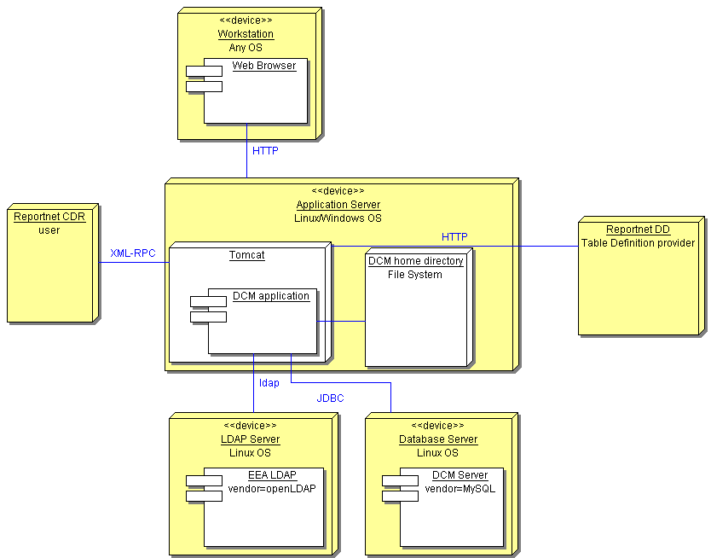
Figure 8 - The DCM Deployment diagram
Application server
It represents a server device which is running under the Red Hat Enterprise Linux. In case of the standalone DCM installations, this device can run under Linux or the MS Windows since Apache foundation is providing Tomcat installations for these OS. The Tomcat application server will be installed on this device. Deployment of the REPORTNET DCM will take place under this Tomcat instance. The Tomcat instance will handle all communication initiated from the outside world. This includes HTTP requests, as well as XML-RPC calls. As shown in Figure 8 the DCM application will communicate with the LDAP and Database server.
Database Server
This is a server device running under Red Hat Enterprise Linux. In case of the standalone DCM installations, this device can run under Linux or the MS Windows since MySQL foundation is providing MySQL Db Server installations for these OS. MySQL database version 4.1 will be installed on this device. The DCM database will be deployed under this MySQL installation.
LDAP Server
This server device represents the existing informational structure of the EEA. It keeps the OpenLDAP server used as credentials storage. The DCM application will use it in order to authenticate users accessing the web site.
Organizational stakeholders who will install the standalone DCM application will be able to use the same EEA LDAP server, but they can also use another LDAP server installed (maybe) at their premises. The only important rule that shall be respected is that they will need LDAP version 3 compatible LDAP server.
Workstation
A personal computer used by the users who want access to the DCM application. The installed component which will interact with the DCM shall be the internet browsers as described in the DCM FSD document.
Reportnet DD application
It is a Reportnet application. DD provides the table definition to the DCM application through the HTTP protocol.
Reportnet CDR application
It is a Reportnet application. CDR uses DCM XML Conversion functions through the XML-RPC protocol.

Appendix A - Interactions diagrams
Interfaces described in section 4.1 will be used to allow interactions between system modules and interactions between external systems and the DCM.
The following sequence diagrams show these interactions in order to accomplish system functions.
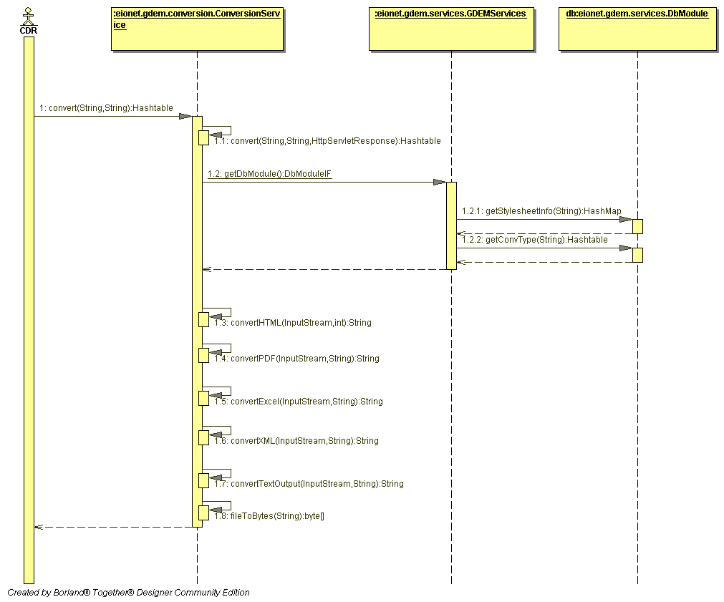
Figure 9 - Convert delivered XML with hand-coded stylesheet sequence diagram

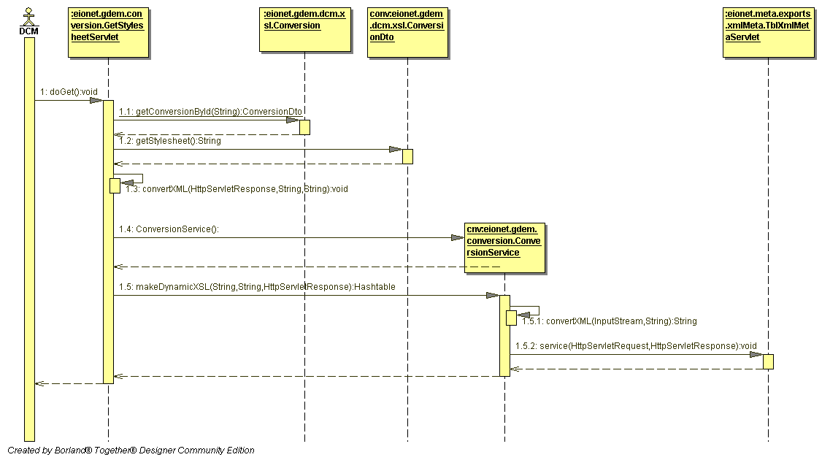
Figure 10 - Generate Stylesheet for a Table defined in DD sequence diagram

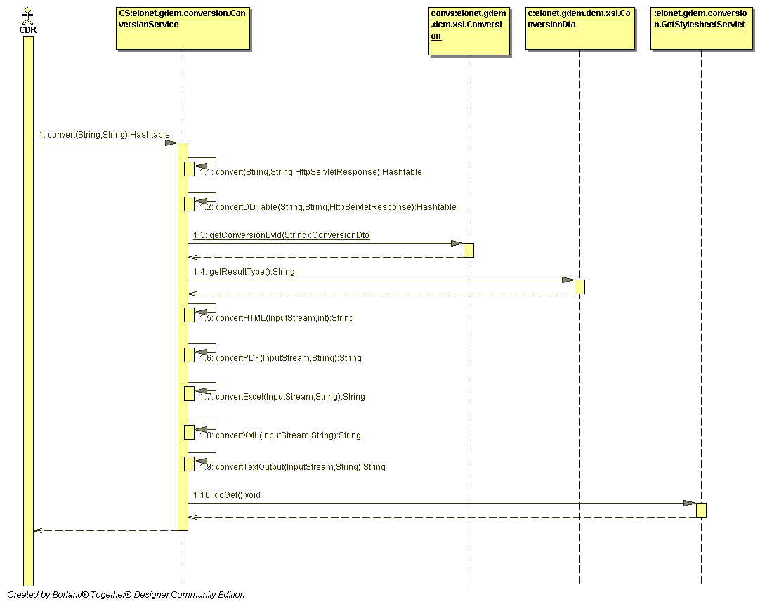
Figure 11 - Convert delivered XML with generated stylesheet sequence diagram
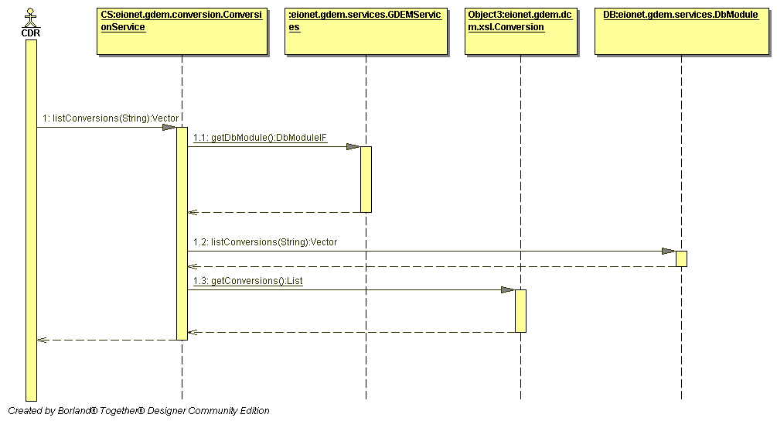
Figure 12 - Get List of Conversion sequence diagram

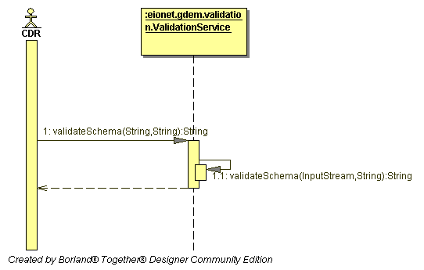
Figure 13 - Validation sequence diagram

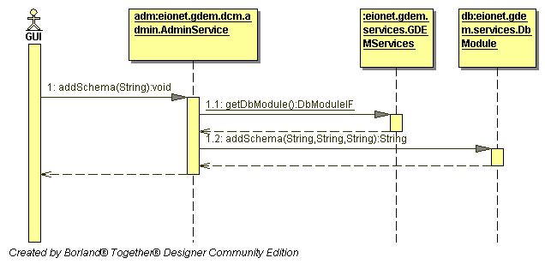
Figure 14 - Add hand-coded XML schema sequence diagram

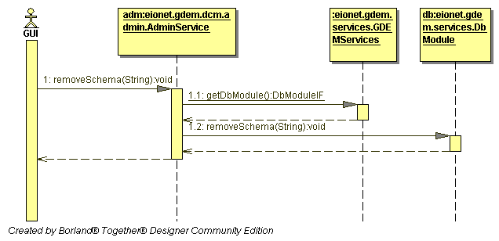
Figure 15 - Remove hand-coded XML schema sequence diagram

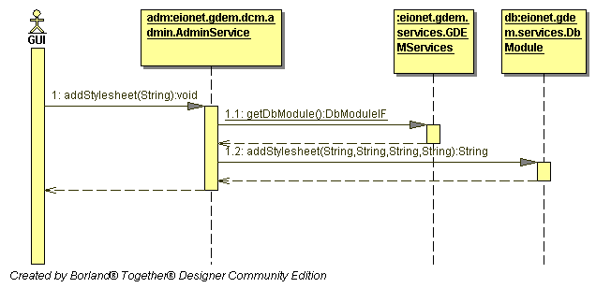
Figure 16 - Add hand-coded stylesheet sequence diagram

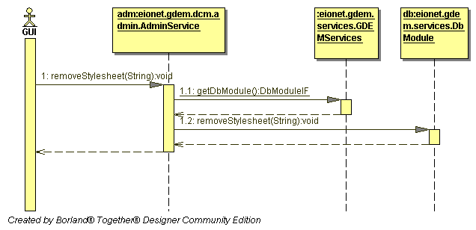
Figure 17 - Remove hand-coded stylesheet sequence diagram

It is important to stress that the REPORTNET DCM will be developed and tested with the outlined external libraries.
For more info please see: Web-Tier Application Framework Design

